Description
Title of Invention : Apparatus for organic waste treatment
Technical Field
- The present invention relates to the treatment of household waste. Specifically, the invention relates to an apparatus being used to produce organic fertilizers from organic waste from daily activities at home, office cafeteria, farm, factory, etc.
Background Art
- Down through the years, the collection and classification of waste in Vietnam, as well as everywhere in the world, have gained more and more attention. Some countries have well implemented the collecting and sorting of waste from households, public places to waste treatment plants. However, in many other countries, including Vietnam, the sorting of waste at source hasn’t been well implemented. It can be said that, currently, it is impossible to separate waste at source. After studying people's behavior in daily life, the inventor realized that the devices for temporary storage of waste are not suitable for garbage collection and classification, especially for organic waste (including leftovers, animal and vegetable waste, etc.). Since waste is stored in the garbage can for a while before being collected and transported to a centralized place for treatment, the decomposition of organic waste can create an unpleasant smell. In order to avoid stench, people often use multiple plastic bags to store these organic wastes at home before sending them to garbage trucks or landfills. This complicates the sorting of waste at treatment plants.
- The following patent documents are provided for reference:
- Patent document 1: Publication of international patent application No. WO 2013/128351 A1
- Patent document 2: Publication of international patent application No. WO 2008/000510
- Patent document 3: Publication of Spanish patent application No. ES 2471176 A1
- Patent document 4: Publication of Russian Federation Patent No. RU 2401701 C1
- Patent document 5: Publication of Russian Federation Patent No. RU 2579789 C1
- Patent document 6: Publication of Russian Federation Patent No. RU 2595143 C1
Summary of Invention
- The main purpose of the present invention is to prevent stench arising from organic waste kept at home, and to treat organic waste at the source to form composting fertilizers.
- The specific purpose of the present invention is to create an organic waste treatment apparatus that is capable of performing at least one of the following functions: (i) pressing organic waste into contact with the cutters of the crushing unit for a fast and thorough crushing; (ii) automating the probiotic spray operation so that the crushed waste can absorb the probiotics more evenly; (iii) detecting or removing metal objects that accidentally entered the grinding unit, cleaning the grinding unit area, refilling the probiotic container; (iv) periodic mixing of ground and permeated waste with probiotics in order to accelerate the decomposition process and the separation of liquid, methane (CH4) and ammonia (NH3); (v) draining the liquid in the garbage and the liquid that was generated during the process of decomposition; (vi) venting methane (CH4), ammonia (NH3) and other emissions in the process of waste decomposition in order to minimize odors at the place where the apparatus is installed.
- In order to achieve at least one of the above functions, the present invention provides an organic waste treatment apparatus comprising:
- a garbage receiving unit which consists of two compartments: the first compartment hosts a garbage compactor unit which includes the upper inlet corresponding to the first opening of the top cover with a probing door; the second compartment corresponds to the second opening of the top cover with a cover that can be closed/open and an exit door located at the bottom and adjacent to the inlet of a crushing unit;
- the garbage compactor unit has the function of pressing the garbage, from top to bottom, into the cutters of the crushing unit,
- a crushing unit, fixed on the upper part of the structure frame, consisting of: a crushing chamber, a driving shaft, a driven shaft which is mounted horizontally and parallel to the driving shaft, several cutters which are mounted on the driving shaft and the driven shaft for crushing garbage, a first gear transmission connecting the driving shaft to a motor, and a second gear transmission connecting the driving shaft to the driven shaft;
- a mixing unit, positioned underneath the crushing unit, consisting of: a mixing compartment, a mixing shaft connected to the motor with a belt, a mixing compartment cover fixed to the top of the mixing compartment for preventing the material from spilling out during the mixing operation, a mixing compartment door located on the mixing compartment cover for receiving ground garbage from the crushing unit, a discharge outlet located on the wall of the mixing compartment and far from the crushing unit, which can be opened/closed;
- a motor with reversible rotation function, equipped with magnetic starter, current sensor, rev counter, and timer; and
- a control panel to control the functions of this device.
- In accordance with one embodiment of the present invention, the garbage compactor unit consists of: a guiding box fixed to the rear wall of the garbage receiving unit for guiding a rack in vertical motion, a gear-bearing shaft with two shaft ends mounted on two rotating platform on the two side walls of the garbage receiving unit, a gear that is fixed to the gear-bearing shaft, the rack moves in tandem with the gear on the gear-bearing shaft, two cranks that are mounted in two extremities of the shaft to control the rotation of the gear for moving the rack vertically, a garbage presser which is mounted on a garbage presser support located at the lower end of the rack.
- In accordance with another embodiment of the present invention, the mentioned waste treatment apparatus also includes a probiotic spray unit to spray the probiotics and make the probiotics mix evenly into the crushed garbage.
- In accordance with another embodiment of the present invention, the probiotic spray unit includes a probiotic container located inside the first compartment of the garbage receiving unit, a suction pipe for conducting probiotics to a probiotic pump, two nozzles connecting the output of the probiotic pump to a T-shaped connector, and two nozzles connected to the two outputs of the T-shaped connector and fixed onto the wall of the garbage receiving unit.
- In accordance with another embodiment of the present invention, the garbage guiding compartment has a funnel-shaped design with several small holes on the bottom plate for extracting the liquid in the garbage, which will be conducted to a waste liquid container via a drain pipe.
- In accordance with another embodiment of the present invention, the waste liquid container, fixed at the bottom of the structure frame of the said apparatus for catching the waste liquid escaping from the drainage holes located on the bottom of the garbage guiding compartment and the mixing compartment, comprises a mesh tray which is placed inside the waste liquid container for filtering and retaining fine granular material, and a drain hose which is located on the side near the bottom of the waste liquid container for discharging the filtered waste liquid to the outside.
- In accordance with another embodiment of the present invention, the venting unit includes exhaust fans and exhaust pipes to carry methane, ammonia and other emissions generated during the decomposition process to the outside of the said apparatus to be processed according to the demand of use.
- In accordance with another embodiment of the present invention, the mentioned waste treatment apparatus also includes a negative ion generator for deodorizing and killing bacteria in the internal space of this device.
- In accordance with another embodiment of the present invention, wherein the two stages of spiral blades of a mixing shaft are mounted on the same axis but in two opposite directions so that, when the mixing shaft rotates clockwise, the outer spiral blade will push the material located in the area near the wall of the mixing compartment in the direction from the side of the grinding unit towards the outlet of the mixing compartment; the inner spiral blade will push the material located in the area near the center of the mixing shaft in the direction from the side of the discharge port to the side of the grinding unit.
- In accordance with another embodiment of the present invention, a control panel includes: a power on button and a power off button for switching on and off the apparatus; a rotary switch with three positions: the first position controls the motor to perform the function of crushing or discharging, the second position controls the motor to perform the function of periodic mixing, and the third position controls to stop the motor; a button for controlling the probiotic pump; an on/off button for controlling the exhaust fan; an on/off button for controlling the negative ion generator; and an indicator light that will be lit up when the volume of waste in the mixing compartment reaches a predetermined level.
- In some embodiments of the present invention, the said waste treatment apparatus also includes an optical sensor which is located on the side of the mixing compartment and connected to an indicator light on the control panel for giving warning signals when the material in the mixing compartment reaches a predetermined level.
- In some embodiments of the present invention, the mentioned waste treatment apparatus also includes a travel switch, which is fixed to the rear cover of the garbage receiving unit through a support plate close to the probing door and will be activated only when the door is closed, meaning that the apparatus will not operate when the door is open, ensuring the safety of the user.
- In some embodiments of the present invention, a discharge outlet consists of a hinged opening/closing lid and is tightened by bolts with a knob.
- In yet further embodiments of the present invention, the mentioned waste treatment apparatus also includes two wheels which are mounted under the structure frame for easy transportation.
- It should be noted that the technical nature of the present invention is presented in order to introduce concepts related to organic waste treatment apparatus. Detailed description of the present invention will be described below and illustrated with drawings. This section of technical background is not intended to define the essential features of the invention nor to be used in determining the scope of the invention.
Advantageous Effects of Invention
- The present invention introduces several effectiveness: preventing stench (due to the decomposition of organic waste) in the area where this apparatus is located; no need for emptying the trash every day because the crushed waste takes up a smaller volume and can be kept in the mixing compartment for many days until this compartment being full; converting of organic waste into organic fertilizer that can be used for farming.
Brief Description of Drawings
Fig.1
- [Fig.1] is a perspective image from the front view, showing the overall structure and the shape of the organic waste treatment apparatus according to the present invention in the state that the front door 3.1.1 is partially opened, the probing door 4.2 on the top cover is opened, the garbage inlet (inlet of the garbage compartment) is covered.
Fig.2
- [Fig.2] is a perspective image from the back view, showing the overall structure and the shape of the organic waste treatment apparatus according to the present invention in the state that the rear door 3.2.1 is partially opened, the probing door 4.2 on the top cover is opened, the garbage inlet (inlet of the garbage compartment) is opened.
Fig.3
- [Fig.3] is a perspective image from the side and front view, showing the structure of the organic waste treatment apparatus according to the present invention in the state that the covers on both sides, front, and side panels have been removed.
Fig.4
- [Fig.4] is the perspective image of the garbage receiving unit 5 according to the present invention, showing part of the structure of the probing door 4.2 in the open state.
Fig.4A
- [Fig.4A] is a perspective view of the garbage receiving unit 5 of the present invention with the top cover 4 removed showing the position of the limit switch 4.3 and support plate 5.1.
Fig.4B
- [Fig.4B] is a perspective view of top cover 4 being inverted according to the present invention showing the connection with the probing port 4.2.
Fig.4C
- [Fig.4C] is the side view of the garbage receiving unit 5 according to the present invention showing the probing door 4.2 in the open state (switch 4.3.1 is open).
Fig.4D
- [Fig.4D] is the side view of the garbage receiving unit 5 according to the present invention showing the probing door 4.2 in the closed state (switch 4.3.1 is closed).
Fig.5
- [Fig.5] is a perspective image showing the structure of the garbage receiving unit 5 according to the invention.
Fig.5A
- [Fig.5A] is a perspective image showing the internal structure of the garbage receiving unit 5 according to the present invention.
Fig.5B
- [Fig.5B] is a side view showing the structure of the garbage receiving unit 5 according to the present invention.
Fig.6
- [Fig.6] is a perspective image showing the probiotic pump unit 6 which is mounted on the garbage receiver 5 according to the present invention.
Fig.6A
- [Fig.6A] is a perspective image showing the probiotic pump unit 6 according to the present invention.
Fig.6B
- [Fig.6B] is the side view showing the probiotic pump unit 6 mounted on the garbage receiving unit 5 according to the present invention.
Fig.7
- [Fig.7] is a perspective image showing the shape and structure of the garbage receiving unit 5 according to the present invention, with the assembled garbage compactor unit 7, the motor 9 and the crushing unit 8.
Fig.7A
- [Fig.7A] is a perspective image showing the shape and structure of the garbage compactor unit 7 according to the invention.
Fig.7B
- [Fig.7B] is a perspective image showing the shape and structure of the garbage compactor unit 7 according to the present invention, in which one side of the guiding box 7.6 is removed to show the engagement of gear 7.4 and rack 7.3.
Fig.7C
- [Fig.7C] is the side view showing the outer profile of the garbage presser 7.1 in accordance with the rotary trajectory of the cutter 8.5.
Fig.7D
- [Fig.7D] is a perspective image showing the tight connection of the garbage presser 7.1 with the garbage presser support 7.2 and with the rack 7.3 according to the invention.
Fig.7E
- [Fig.7E] is the side view of the garbage receiving unit 5 of the present invention with assembled crushing unit 8 and the compactor unit 7 while the garbage presser 7.1 is in the highest position.
Fig.8
- [Fig.8] is a perspective view showing the gear transmission between the motor 9 and the crushing unit 8.
Fig.8A
- [Fig.8A] is a perspective view showing the crushing unit 8 mounted above the structure frame of the present invention.
Fig.8B
- [Fig.8B] is a perspective view showing the crushing unit mounted above the mixing unit, the belt drive and the gear transmission between the crushing unit and the mixing unit of the present invention.
Fig.9
- [Fig.9] is a perspective view showing the mixing unit 10 mounted onto the structure frame 1, and the waste liquid container 11 below the mixing unit 10.
Fig.9A
- [Fig.9A] is a perspective image showing the mixing unit 10 with the cover of the mixing compartment 10.6 removed, including the mixing compartment 10.1 with the optical sensor 14 and the mixing shaft 10.2 according to the present invention.
Fig.9B
- [Fig.9B] illustrates the mixer shaft 10.2 of to the present invention.
Fig.9C
- [Fig.9C] is the perspective view from below of the mixing compartment 10.1 showing the shape of the mixing chamber 10.1, the location of the drain holes cluster 10.1.3, the position of the discharge outlet 10.1.2 in the closed state according to the present invention.
Fig.9D
- [Fig.9D] is a perspective view showing the shape of the mixing compartment 10.1, the position and structure of the discharge outlet 10.1.2 in open state according to the present invention.
Fig.10
- [Fig.10] is a perspective image showing the waste liquid container 11 that is mounted onto the structure frame 1 according to the present invention.
Fig.10A
- [Fig.10A] illustrates the structure of the structure frame 1 according to the present invention;
Fig.10B
- [Fig.10B] is a perspective view showing the mesh tray 11.1 fitted inside the waste liquid container 11 of the present invention.
Fig.10C
- [Fig.10C] is a drawing showing the structure of the waste liquid container 11 according to the present invention.
Fig.10D
- [Fig.10D] is an illustration of the structure of mesh tray 11.1 of the present invention.
Fig.10E
- [Fig.10E] is an illustration showing the drain pipe 5.14 of the garbage receiving unit 5 connected to the conducting pipe 11.2 of the waste liquid container 11 according to the present invention.
Fig.11
- [Fig.11] is a perspective view from the back of the organic waste treatment apparatus, showing the air venting unit 12 and the back cover 3.2 of the present invention.
Fig.11A
- [Fig.11A] illustrates the structure of the venting unit including the extracting fan 12.3, fan support 12.1, and the exhaust pipe 12.2.
Fig.12
- [Fig.12] is a drawing showing the details on the control panel 13 including: the power on button 13.1 and the power off button 13.2 for turning on/off the said apparatus, the probiotic pump control button 13.3, the exhaust fan on-off button 13.5, the negative ion generator on-off button 13.6, the indicator light 13.4 for indicating when the material in the mixing chamber reaches a predetermined level, the rotary switch 13.7, and the timer 13.8.
Description of Embodiments
- The detailed description below contains references to the accompanying drawings for a better understanding of the technical features of the present invention. All drawings must be consulted in combination with the description in order to fully understand the structure and operating principle of the said apparatus. In addition, it should be understood that the specific examples or specific parameters (if any) given in the following description are for illustrative purposes only, not for the purpose of limiting the scope of patent protection under such parameters. A person with average technical knowledge can completely make changes and adjustments in the structure of the device to bring about an effect equivalent to the invention. Such changes or corrections will obviously be construed as still within the scope of the claim of the invention.
- As shown in Fig.1, Fig.2 and Fig.3, the organic waste treatment apparatus consists of the structure frame 1, the wheels 2, four side covers 3 including the front cover 3.1, the rear cover 3.2, the right cover 3.3 (view from front to back), and the left cover 3.4, the top cover 4, the garbage collector 5, the probiotic spray unit 6, the garbage compactor unit 7, the crushing unit 8, the motor 9, the mixing unit 10, the waste liquid container 11, the air venting unit 12, the control panel 13 to control the function of this apparatus, and an optical sensor 14.
- As shown in Fig.1, the front cover 3.1 also includes the front door 3.1.1 providing access to discharge outlet 10.1.2 of the mixing unit 10. As shown in Fig.2, the rear cover 3.2 also includes the rear door 3.2.1 providing access to the mesh tray 11.1 of the waste liquid container 11.
- As shown in Fig.4, Fig.4A, and Fig.4B, the top cover 4 is fixed to the top face of the garbage receiving unit 5 through the supports 5.2 and the supports 4.5. In the first compartment of the garbage receiving unit 5, corresponding to the first opening of the top cover 4, the probing door 4.2 is fixed on the top cover 4 with the hinge 4.2.3 where the swinging leaf 4.2.3A is fixed (e.g., by welding) to the probing door 4.2, the fixed leaf 4.2.3B is fixed (e.g., by welding) to the top cover 4, the swinging leaf 4.2.3A and the fixed leaf 4.2.3B rotate around the hinge pin 4.2.3C. In the second compartment of the garbage receiving unit 5, corresponding to the second opening of the top cover 4, the cover 4.1 is equiped with the handle 4.1.1 which can be closed or opened to collect garbage.
- As shown in Fig.4, Fig.4A, Fig.4B, and Fig.5A, the support plate 5.1 is fixed (e.g., by welding) to the rear cover 5.10 of the garbage receiving unit 5. The limit switch 4.3 (normally open) is installed in the support plate 5.1 so that the push button 4.3.1 of the limit switch 4.3 goes through the hole 4.4 of the top cover 4 and points towards the probing door 4.2.
- As shown in Fig.4C, corresponding to the probing door 4.2 in the open state, the probing door 4.2 does not affect the push button 4.3.1 of the limit switch 4.3, causing the electrical circuit to open. Hence, the organic waste treatment apparatus will not work.
- As shown in Fig.4D, corresponding to the probing door 4.2 in the closed state, the probing door 4.2 presses on the push button 4.3.1 of the limit switch 4.3, causing the electrical circuit on the limit switch 4.3 to close. Hence, the organic waste treatment apparatus is in ready-to-operate state.
- By arranging the probing door 4.2 and the limit switch 4.3 as shown in Fig.4, Fig.4A, Fig.4B, Fig.4C, and Fig.4D, it is ensured that the said apparatus will not operate when the probing door 4.2 is open, thus ensuring the safety of the user.
- As shown in Fig.5, Fig.5A, and Fig.5B, garbage receiving unit 5 has the front cover 5.11 consisting of three flat plates (5.11.1, 5.11.2, and 5.11.3). The middle wall 5.3 of the garbage receiving unit 5 consists of three flat plates (5.3.1, 5.3.2 and 5.3.3). The garbage receiving unit 5 has the rear cover 5.10 with the rear cover bracket 5.10.1 for increasing the rigidity of the garbage guiding unit in the garbage compactor unit 7 (Fig.7E). The support plate 5.1 that supports the limit switch 4.3 is fixed onto the rear cover 5.10.
- As shown in drawings Fig.5, Fig.5A, and Fig.5B, the garbage receiving unit 5 has the two side walls 5.15 and 5.16. On these two side walls are fixed two support plates 5.7 which are used for mounting the two rotating supports 7.8 (refer to Fig.7) of the garbage compactor unit 7. The two side walls 5.15 and 5.16 also have two additional holes 5.8 for installing the two nozzles 6.8. The garbage receiving unit 5 is basically made up of the front wall 5.11, the middle wall 5.3, the rear cover 5.10, the side wall 5.15 and the side wall 5.16. The garbage receiving unit 5 includes two adjacent compartments: the rear cover 5.10 and the middle wall 5.3 combined with two side walls 5.15 and 5.16 to form the first compartment; the front cover 5.11 and the middle wall 5.3 combine with two side walls 5.15 and 5.16 to form the second compartment. These two compartments are adjacent at the outlet 5.9 located at the bottom of garbage receiving unit 5.
- As shown in Fig.5A and Fig.5B, the garbage receiving unit 5 has the second compartment as the garbage guiding compartment. This garbage guiding compartment has two parts: the first part has a funnel shape to receive the garbage, the second part being located at the bottom of the garbage receiving unit guides the garbage to the inlet 8.1.1 of the crushing unit 8. The flat plate 5.11.3 located at the bottom of the guiding compartment has many small holes 5.12 allowing the liquid in the garbage to escape to the gutter 5.13. The liquid trough 5.13 has rectangular box shape (or any other shape with suitable structure) with its sides fixed to the flat plate 5.11.3. The bottom surface of the liquid trough 5.13 has the drain pipe 5.14 connected to the drain pipe 5.17 (refer to Fig.10E) to conduct the waste liquid to the waste liquid container 11.
- As shown in Fig.5, Fig.6, and Fig.6B, the shield 5.4 fits into the slot 5.6 together with the middle wall 5.3 which serves to hold the probiotic container 6.2. The groove 5.5 on the wall 5.16 of the garbage receiving unit 5 serves as the drain for the suction pipe 6.3.
- As shown in Fig.6, Fig.6A, and Fig.6B the probiotic spraying unit 6 consists of: the probiotic container 6.2 with the inlet 6.2.1, the cover 6.2.2 with the venting hole A, the suction pipe 6.3 with the inlet fitted into the suction tube mounting hole B, the suction pipe 6.3 fitted to the probiotic pump inlet 6.1, the probiotic pipe 6.4 connecting the probiotic pump outlet 6.1 to the T-shaped connector 6.5, the two probiotic conducting pipes 6.6 and 6.7 connect the two outputs of the T-shaped connector 6.5 to the two spray nozzle 6.8. These two spray nozzles 6.8 are fixed in two holes 5.8 (see Fig.5) on the two walls of the garbage receiving unit 5 to perform the probiotic spray.
- As shown in Fig.7, Fig.7A, Fig.7B, and Fig.7E, the garbage compactor unit 7 consists of: the guiding box 7.6 that is fixed onto the rear wall 5.10 of the garbage receiving unit thanks to two angle brackets 7.7, the rack 7.3 which can translate vertically, the gear 7.4 is permanently linked to the gear carrier 7.5, the two rotating supports 7.8 that support the two ends of the gear carrier 7.5, the side walls 5.15 and 5.16 where the rotating support 7.8 being mounted, the gear 7.4 that engages with the rack 7.3, the two handwheels 7.9 which are connected to the gear 7.4 via the gear carrier 7.5.
- As shown in Fig.7C and Fig.7D, the garbage presser support 7.2 holds the garbage presser 7.1 at the lower end of the rack 7.3 using fasteners (e.g., bolts, nuts, screws). The garbage presser 7.1 has an outer profile adapting to the rotational trajectory of the cutter 8.5 to ensure that it does not collide with the cutter.
- As shown in Fig.7C, the garbage presser 7.1 is in the lowest position and is in contact with the cutter 8.5. As shown in Fig.7E, the garbage presser 7.1 is at the highest position. When the garbage presser 7.1 is in this position, the opening between the garbage presser 7.1 and the crushing unit inlet 8.1.1 of the crushing unit 8 will allow the garbage to be collected from the garbage compartment.
- As shown in Fig.8, the electric motor 9 drives the gear 9.1. The gear 9.1 engages the gear 8.4. The gear 8.4 is mounted on the driving shaft 8.2 of the crushing unit 8. The inlet 8.1.1 of crushing unit 8 is installed adjacent to the outlet 5.9 of the garbage receiving unit 5. The mixing unit 10 is located on the structure frame 1 and below the crushing unit 5. The bottom of structure frame 1 has the wheels 2 for easy transportation of the organic waste treatment apparatus.
- As shown in Fig.8 and Fig.8A, the motor 9 and the crushing unit 8 are fixed on the top side 1.1 of the structure frame 1 through the cover of the mixing compartment 10.6. The crushing unit 8 includes the crushing chamber 8.1 and the grinding mechanism arranged inside the crushing chamber. The grinding mechanism consists of the driving shaft 8.2 and the driven shaft 8.3 which are mounted horizontally and parallel to each other. These two shafts are supported by structures that are fixed on the walls of the crushing chamber 8.1. Several cutters 8.5 are mounted on the driving shaft 8.2 and on the driven shaft 8.3 for crushing waste. The drive shaft 8.2 is driven by the motor 9 through a first gear transmission consisting of the gear 9.1 and the gear 8.4. The driving shaft 8.2 will then drive the driven shaft 8.3 through the second gear transmission consisting of the drive gear 8.6 mounted on driving shaft 8.2 and the driven gear 8.7 mounted on the driven shaft 8.3.
- As shown in Fig.8B, Fig.9, and Fig.9A, the mixing unit 10 is located on the top side 1.1 of the structure frame 1 and below the crushing unit 8 so that the waste after being crushed falls into the mixing unit 10. The mixing unit 10 consists of: the mixing compartment 10.1, the mixing shaft 10.2 with two shaft ends which can rotate on two rotating supports (e.g. two ball bearings or similar structures, not shown in the figures) is fixed on two walls at both ends of the mixing compartment 10.1, the mixing shaft 10.2 is driven by the motor 9 through a belt drive consisting of the driving pulley 10.3, the driven pulley 10.4 and the belt 10.5. The driving pulley 10.3 is mounted on the driving shaft 8.2 of the crushing unit 8.
- As shown in Fig.9 and Fig.9A, the wall 10.1.1 on the top of the mixing compartment 10.1 is designed to be removable to facilitate assembly and repair. This wall can be fixed to the mixing compartment 10.1 using bolts and nuts, or nails.
- As shown in Fig.8B and Fig.9, the mixing compartment cover 10.6 is fixed to the top face of mixing compartment 10.1 to keep the material (garbage) from spilling out during the mixing. The mixing compartment door 10.6.1 is located on the cover of mixing compartment 10.6 and directly below the crushing unit 8.
- As shown in Fig.8, Fig.9C and Fig.9D, the discharge outlet 10.1.2 is located on the wall at the top of the mixing compartment 10.1, far away from the mixing compartment door 10.6.1 and the crushing unit 8. The discharge outlet 10.1.2 includes a set of hinges 10.1.2A for opening/closing the discharge outlet cover 10.1.2D, the bolt with knob 10.1.2B and threaded holes 10.1.2C for fastening the discharge outlet cover 10.1.2D to the wall of the mixing compartment 10.1.
- As shown in Fig.9C, Fig.9D, the mixing compartment 10.1 has the curved bottom surface with clusters of tiny drainage holes 10.1.3 along the length of the mixing compartment 10.1 to allow the liquid in this compartment to drain into the waste liquid container 11 (refer to Fig.9).
- As shown in Fig.9, Fig.9C and Fig.9D, the optical sensor 14 is located on the side of mixing compartment 10.1 for detecting the level of material in the mixing compartment. The optical sensor 14 is connected to the indicator light 13.4 on the control panel 13 (refer to Fig.12) to give warning signals when the material in the compartment reaches a predetermined level. For example, when the material in the compartment reaches a level that can affect the operation of the mixing shaft 10.2, a warning signal will be shown on the control panel.
- As shown in Fig.9B, the mixing shaft 10.2 consists of two spiral blades: the outer spiral blade 10.2.1 and the inner spiral blade 10.2.2. These two blades are mounted on the same vertical shaft 10.2.3 but in two opposite directions. When the mixing shaft rotates clockwise, the outer spiral blade 10.2.1 will push the material located in the area near the wall of the mixing compartment in the direction from the side of the crushing unit towards the outlet of the mixing compartment; the inner spiral blade 10.2.2 will push the material located in the area near the center of the mixing shaft in the direction from the side of the discharge port to the side of the crushing unit.
- As shown in Fig.10, Fig.10A and Fig.10C, the waste liquid container 11 is placed in the void 1.3 formed at the bottom 1.2 of the structure frame 1. The support plate 11.4 of the waste liquid container 11 is placed on the bottom 1.2 of structure frame 1. The inlet pipe 11.2 is connected to the drain pipe 5.14. The drain pipe 11.3 of the waste liquid container is used to discharge waste liquid to the outside.
- As shown in Fig.10B, Fig.10C and Fig.10D, the waste liquid container 11 is designed as a drawer with the top opening 11B (in Fig.10C). The front side has a rectangle shaped door 11A. Inside this drawer there are the support plate 11.5 and the mesh tray 11.1 which is supported by the support plate 11.5 of the waste liquid container 11. The mesh tray 11.1 is used for filtering and retaining fine granular materials from the waste liquid.
- As shown in Fig.10B and Fig.10D, the mesh tray 11.1 has the bottom surface 11.1.1 as a mesh panel. The handle 11.1.2 is used to pull the mesh tray 11.1 out of the waste liquid container 11.
- As shown in Fig.10E, the drain pipe 5.17 is used to connect the drain pipe 5.14 of garbage receiving unit 5 to the inlet pipe 11.2 of the waste liquid container 11.
- As shown in Fig.11 and Fig.11A, the air venting unit 12 is fitted in the cutout 3.2.2 on rear cover 3.2. The air venting unit 12 includes the mounting bracket 12.1, the extracting fan 12.3, and the exhaust pipe 12.2.
- In accordance with some specific embodiments of the present invention, a negative ion emitter (not shown) may be located at several suitable locations in the organic waste treatment apparatus to remove odors from the generated gas during the decomposition process before being vented. For example, negative ion generators can be placed near locations that are frequently accessed by users, such as: the entrance of the garbage receiving unit 5, the front door 3.1.1, the rear door 3.2.1.
- As shown in Fig.12, the control panel 13 includes the power on button 13.1, the power off button 13.2, the probiotic pump control button 13.3, the venting fan on-off button 13.5, the negative ion generator on-off button 13.6, the indicator light 13.4 to indicate that the material in the mixing chamber has reached a predetermined level.
- As shown in Fig.12, the control panel 13 also includes the rotary switch 13.7 with three positions (three dashes near the rotary switch) corresponding to three functions. The first position on the left controls the motor to perform the crushing or discharging function, the second position in the middle controls the motor to perform the periodic mixing function, and the third position on the right stops the motor 9.
- As shown in Fig.12, the control panel 13 also includes the timer 13.8 which is used to set the duration of the mixing cycle including mixing time and standby time.
- As shown in Fig.3, Fig.8B, Fig.9A, and Fig.12, when the rotary switch 13.7 is in the first position, the motor 9 will rotate so that the driving shaft 8.2 and the driven shaft 8.3 of the crushing unit 8 rotates in opposite directions to perform the crushing function. The mixing shaft 10.2 also rotates in the direction that the outer spiral blade 10.2.1 will send the crushed waste towards the discharge outlet 10.1.2 of the mixing compartment 10.1, which is in the closed state.
- As shown in Fig.3, Fig.8B, Fig.9A, and Fig.12, when the rotary switch 13.7 is in the first position, the motor 9 will rotate so that the driving shaft 8.2 and the driven shaft 8.3 of the crushing unit 8 rotate in opposite directions. The mixing shaft 10.2 also rotates in the direction that the outer spiral blade 10.2.1 will bring the crushed waste towards the discharge outlet 10.1.2 of the 10.1 mixing compartment. In order to perform the discharge function, the discharge outlet 10.1.2 will be left open.
- The motor 9 with reversing function is equipped with a magnetic starter, a current sensor, a revolution counter (not shown in the figures), a timer to be able to perform crushing function, discharge function and periodic mixing function.
- The probiotic pump 6.1 is equipped with a magnetic starter, a timer (not shown in the figures), which performs the function of injecting probiotics and automatically turns off after a predetermined interval. The determination of the injection time will be based on the amount of probiotics to be pumped and the pump capacity.
- The operating principle of the organic waste treatment apparatus of the present invention is shown below, with reference to Fig.3.
- First of all, liquid probiotics will be loaded into the probiotic container 6.2 with a concentration (see probiotic manufacturer's instructions) sufficient to handle a full batch of waste in the mixing compartment 10.1. This volume of probiotics will be calculated depending on the capacity of the mixing compartment 10.1. Determining the amount of probiotics to be injected will depend on the amount of garbage put in and the time the pump is in operation. The button 13.1 is used to turn on the apparatus. The button 13.5 is used to turn on the venting fan. And the button 13.6 is used to turn on the negative ion generator.
- When the organic waste is introduced into the garbage compartment for entering the crushing unit 8, the liquid mixed in the waste, if any, will flow along the bottom of the flat plate 5.11.3 into the liquid trough 5.13 and then along the drain pipe 5.17, and finally into the waste liquid container 11 (refer to Fig.5A and Fig.10E). Pressing the control button of the probiotic pump 13.3 and turning the rotary switch 13.7 to the first position for the device to perform the function of crushing organic waste. Turning the handwheel 7.9 to press down the garbage presser 7.1, thus pressing the waste towards the cutters of the crushing unit 8. The driving shaft 8.2 of the crushing unit 8 will drive the mixer shaft 10.2 through a belt (refer to Fig.8B). The garbage after being crushed will automatically fall into the mixing compartment 10.1. At this stage, the liquid generated from the organic waste is drained into the waste liquid container 11 (refer to Fig.9). This liquid will flow through the drain pipe 11.3 to drain or to be collected as liquid fertilizer. The mixture of crushed organic waste and probiotics in the mixing compartment 10.1 will be pushed by the mixing shaft 10.2 towards the discharge outlet 10.1.2. At this stage, the discharge outlet is closed.
- If the rotary switch 13.7 points at the third position, the motor 9 will stop. If the rotary switch 13.7 is at the second position, the apparatus will perform a periodic mixing in order to speed up the decomposition of the waste. Liquid, methane (CH4) and ammonia (NH3) will be separated from the garbage.
- According to a specific example of the present invention, turning rotary switch 13.7 to the second position to initiate a periodic mixing function consisting of the following operations: the mixing shaft rotates five revolutions clockwise, then automatically reverse the rotation of five revolutions counterclockwise, and so on. This will be repeated for five minutes and then stop for one hour. The apparatus will then automatically repeat the next mixing cycle until the rotary switch 13.7 is turned to the third position to stop.
- In case the mixing compartment 10.1 is filled with garbage to a predetermined level that can be detected by the optical sensor 14, the indicator light 13.4 will light up to warn the user to take out the compost mixture. Turning the rotary switch 13.7 to the first position will turn on the motor 9. The mixing shaft 10.2 will rotate to push the manure mixture towards the discharge outlet 10.1.2 which is opened to push the manure mixture out for storage and composting.
Reference Signs List
- 1: structure frame
1.1: top side
1.2: bottom side
1.3: void
2: wheel
3: covers (3.1, 3.2, 3.3, 3.4)
3.1: front cover
3.1.1: front door
3.2: rear cover
3.2.1: rear door
3.2.2: cutout
3.3: right cover
3.4: left cover
4: top cover
4.1: cover
4.1.1: handle (of cover)
4.2: probing door
4.2.1: transparent glass panel
4.2.2: handle (of the probing door)
4.2.3: hinge
4.2.3A: swinging leaf
4.2.3B: fixed leaf
4.2.3C: hinge pin
4.3: limit switch
4.3.1: limit switch button
4.4: hole
4.5: bracket
5: garbage receiving unit
5.1: support plate
5.2: bracket
5.3: middle wall
5.3.1, 5.3.2, 5.3.3: three flat plates of the middle wall
5.4: shield
5.5: groove
5.6: slot
5.7: support plates for mounting the rotating supports
5.8: holes for mounting two nozzles
5.9: outlet of the garbage receiving unit
5.10: rear cover
5.10.1: rear cover bracket
5.11: front cover
5.11.1, 5.11.2, 5.11.3: three flat panels of front cover
5.12: small holes at the bottom of the garbage guiding unit
5.13: liquid trough
5.14: drain pipe
5.15, 5.16: side walls
5.17: drain pipe
6: probiotic spray unit
6.1: probiotic pump
6.2: probiotic container
6.2.1: probiotic container inlet
6.2.2: cover
A: air outlet
6.3: suction pipe
B: suction pipe mounting hole
6.4: probiotic conducting pipe
6.5: T shaped connector
6.6, 6.7: probiotic conducting pipes
6.8: nozzles
7: garbage compactor unit
7.1: garbage presser
7.2: garbage presser support
7.3: rack
7.4: gear
7.5: the gear carrier
7.6: guiding box
7.7: angle bracket
7.8: rotating support
7.9: handwheel
8: crushing unit
8.1: crushing chamber
8.1.1: crushing unit inlet
8.2: driving shaft of the crushing unit
8.3: driven shaft of the crushing unit
8.4 and 9.1: gears of first gear transmission
8.5: cutter
8.6: driving gear of second gear transmission
8.7: driven gear of the second drive driven gear
9: motor
10: mixing unit
10.1: mixing compartment
10.1.1: wall on the top of the mixing compartment
10.1.2: discharge outlet
10.1.2A: hinge
10.1.2B: bolt with knob
10.1.2C: threaded hole
10.1.2D: discharge outlet cover
10.1.3: drain holes cluster
10.2: mixing shaft
10.2.1: outer spiral blade
10.2.2: inner spiral blade
10.2.3: vertical shaft
10.3: driving pulley
10.4: driven pulley
10.5: belt
10.6: mixing compartment cover
10.6.1: mixing compartment door
11: waste liquid container
11.1: mesh tray
11.1.1: bottom surface of the mesh tray
11.1.2: handle to pull the mesh tray
11.2: inlet pipe
11.3: drain pipe
11.4, 11.5: support plate of the sewage tank
11A: rectangle-shaped door
11B: top opening
12: air venting unit
12.1: mounting bracket
12.2: exhaust pipe
12.3: extracting fan
13: control panel
13.1: power on button
13.2: power off button
13.3: probiotic pump control button
13.4: indicator light
13.5: venting fan on-off button
13.6: negative ion generator on-off button
13.7: rotary switch
13.8: timer
14: optical sensor

Claims
- An apparatus for organic waste treatment that comprises:
- a garbage receiving unit (5) which consists of two compartments: the first compartment hosts a garbage compactor unit (7) which includes the upper inlet corresponding to the first opening of the top cover (4) with a probing door (4.2); the second compartment corresponds to the second opening of the top cover (4) with a cover (4.1) that can be closed/open and an exit door located at the bottom and adjacent to the inlet of a crushing unit (8);
- the garbage compactor unit (7) has the function of pressing the garbage, from top to bottom, into the cutters of the crushing unit;
- a crushing unit (8), fixed on the upper part of the structure frame, consisting of: a crushing chamber (8.1), a driving shaft (8.2), a driven shaft (8.3) which is mounted horizontally and parallel to the driving shaft, several cutters (8.5) which are mounted on the driving shaft (8.2) and the driven shaft (8.3) for crushing garbage, a first gear transmission connecting the driving shaft to a motor (9), and a second gear transmission connecting the driving shaft to the driven shaft;
- a mixing unit (10), positioned underneath the crushing unit (8), consisting of: a mixing compartment (10.1), a mixing shaft (10.2) connected to the motor (9) with a belt, a mixing compartment cover (10.6) fixed to the top of the mixing compartment (10.1) for preventing the material from spilling out during the mixing operation, a mixing compartment door (10.6.1) located on the mixing compartment cover (10.6) for receiving ground garbage from the crushing unit (8), a discharge outlet (10.1.2) located on the wall of the mixing compartment (10.1) and far from the crushing unit (8), which can be opened/closed;
- a motor (9) with reversible rotation function, equipped with magnetic starter, current sensor, rev counter, and timer; and
- a control panel (13) to control the functions of this device.
- The apparatus according to claim 1, wherein the garbage compactor unit (7) consists of: a guiding box (7.6) fixed to the rear wall of the garbage receiving unit for guiding a rack (7.3) in vertical motion, a gear carrier (7.5) with two shaft ends mounted on two rotating supports (7.8) on the two side walls (5.15, 5.16) of the garbage receiving unit (5), a gear (7.4) that is fixed to the gear carrier (7.5), the rack (7.3) moves in tandem with the gear (7.4), two handwheels (7.9) that are mounted in two extremities of the gear carrier to control the rotation of the gear for moving the rack vertically, a garbage presser (7.1) which is mounted on a garbage presser support (7.2) located at the lower end of the rack.
- The apparatus according to claim 1 or 2, wherein further includes a probiotic spray unit to spray the probiotics and make the probiotics mix evenly into the crushed garbage.
- The apparatus according to claim 3, wherein the probiotic spray unit (6) includes a probiotic container (6.2) located inside the first compartment of the garbage receiving unit (5), a suction pipe (6.3) for conducting probiotics to a probiotic pump (6.1), two nozzles (6.8) connecting the output of the probiotic pump to a T-shaped connector (6.5), and two nozzles connected to the two outputs of the T-shaped connector and fixed onto the wall of the garbage receiving unit (5).
- The apparatus according to any of the preceding claims, wherein the garbage receiving unit (5) has a funnel-shaped design with several small holes (5.12) on the bottom plate for extracting the liquid in the garbage, which will be conducted to a waste liquid container (11) via a drain pipe (5.17).
- The apparatus according to any of the preceding claims, wherein the waste liquid container (11), fixed at the bottom of the structure frame (1) of the said apparatus for catching the waste liquid escaping from the drainage holes (10.1.3) located on the bottom of the garbage guiding compartment and the mixing compartment, comprises a mesh tray (11.1) which is placed inside the waste liquid container for filtering and retaining fine granular material, and a drain hose (11.3) which is located on the side near the bottom of the waste liquid container for discharging the filtered waste liquid to the outside.
- The apparatus according to any of the preceding claims, wherein the venting unit includes exhaust fans (11.3) and exhaust pipes (12.2) to carry methane, ammonia and other emissions generated during the decomposition process to the outside of the said apparatus to be processed according to the demand of use.
- The apparatus according to any of the preceding claims, wherein further includes a negative ion generator for deodorizing and killing bacteria in the internal space of this device.
- The apparatus according to any of the preceding claims, wherein the two stages of spiral blades of a mixing shaft are mounted on the same axis but in two opposite directions so that, when the mixing shaft rotates clockwise, the outer spiral blade (12.2.1) will push the material located in the area near the wall of the mixing compartment in the direction from the side of the grinding unit towards the outlet of the mixing compartment; the inner spiral blade (10.2.2) will push the material located in the area near the center of the mixing shaft in the direction from the side of the discharge port to the side of the grinding unit.
- The apparatus according to any of the preceding claims, wherein a control panel (13) includes: a power-on button (13.1) and a power-off button (13.2) for switching on and off the apparatus; a rotary switch (13.7) with three positions: the first position controls the motor to perform the function of crushing or discharging, the second position controls the motor to perform the function of periodic mixing, and the third position controls to stop the motor; a button for controlling the probiotic pump (13.3); an on/off button for controlling the venting fan (13.5); an on/off button for controlling the negative ion generator; and an indicator light that will be lit up when the volume of waste in the mixing compartment reaches a predetermined level.
- The apparatus according to any of the preceding claims, wherein further includes an optical sensor (14) which is located on the side of the mixing compartment and connected to an indicator light (13.4) on the control panel for giving warning signals when the material in the mixing compartment reaches a predetermined level.
- The apparatus according to any of the preceding claims, wherein further includes a travel switch (4.3), which is fixed to the rear cover (5.10) of the garbage receiving unit (5) through a support plate close to the probing door (4.2) and will be activated only when the door is closed, meaning that the apparatus will not operate when the door is open, ensuring the safety of the user.
- The apparatus according to any of the preceding claims, wherein a discharge outlet (10.1.2) consists of a hinged opening/closing lid and is tightened by bolts with a knob.
- The apparatus according to any of the preceding claims, wherein further includes two wheels (2) which are mounted under the structure frame for easy transportation.

Abstract
The present invention relates to an organic waste treatment apparatus consisting of a garbage receiving unit (5), a probing door (4.2), a garbage compactor unit (7), a crushing unit fixed to the upper part of the structure frame (1), a mixing unit positioned underneath the crushing unit (8), a motor (9) that drives all movements of the apparatus using belt drive and gear drive, and a control panel (13) controlling the functions of this device.

[Fig. 1]

[Fig. 2]

[Fig.3]
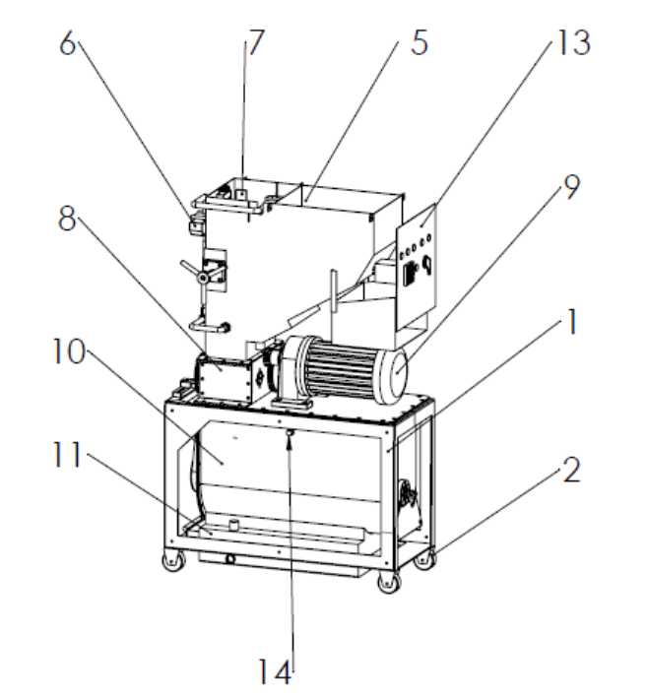

[Fig.4]
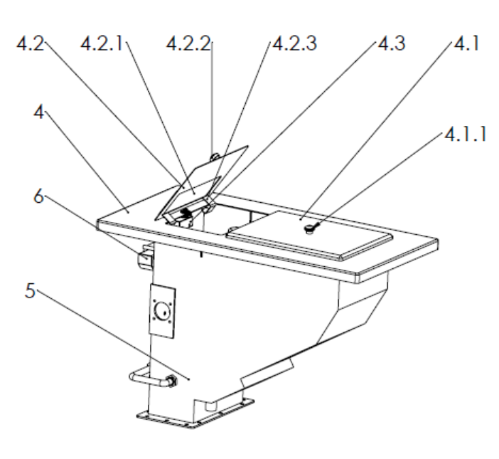

[Fig.4A]
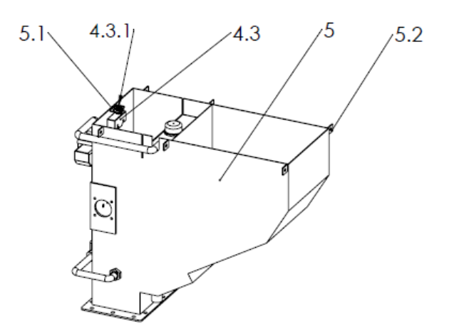
[Fig.4B]
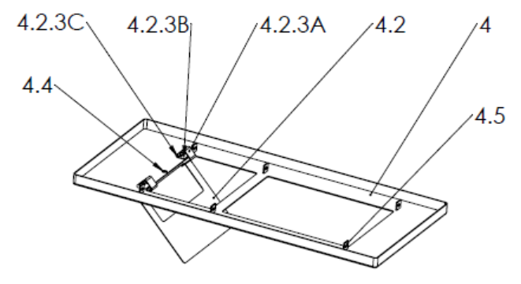

[Fig.4C]
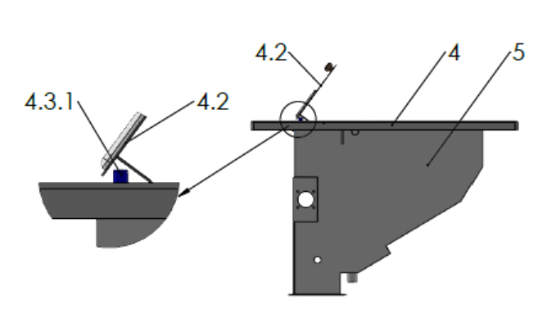
[Fig.4D]
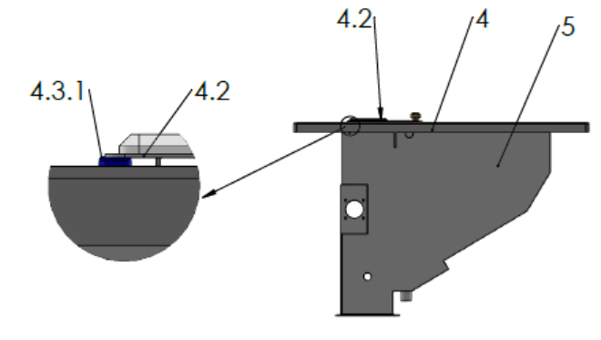

[Fig.5]
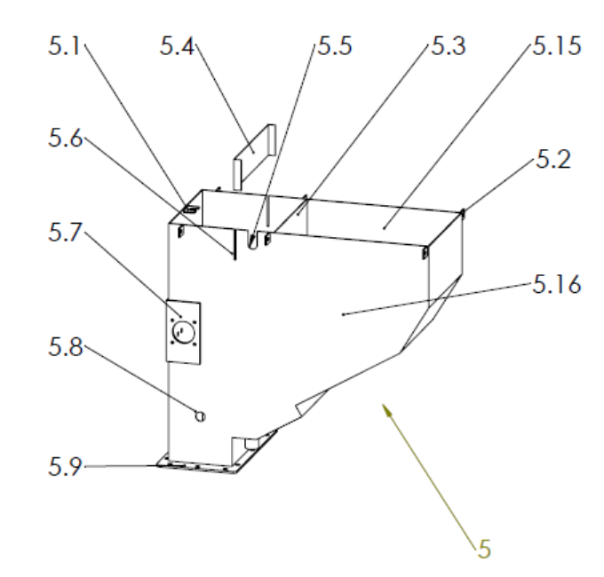
[Fig.5A]
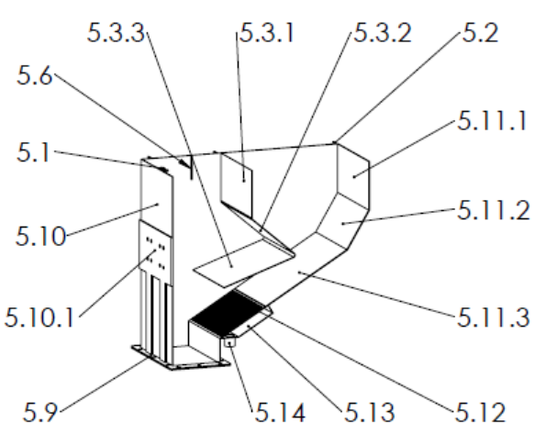

[Fig.5B]
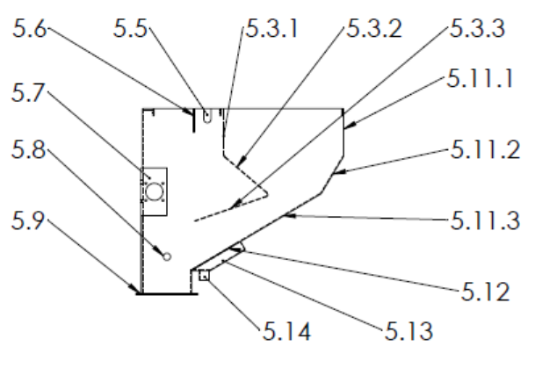
[Fig.6]
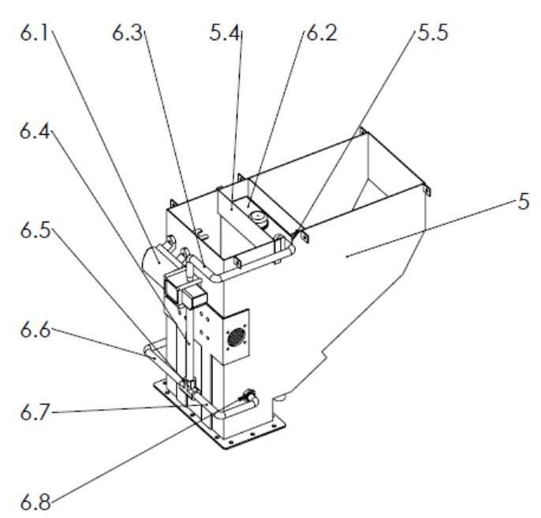

[Fig.6A]
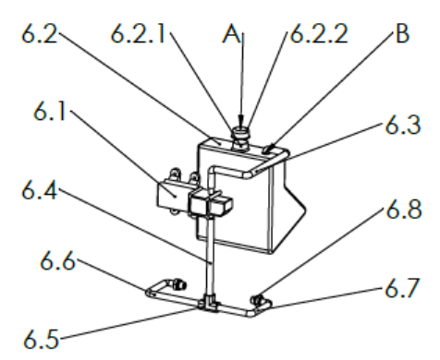
[Fig.6B]
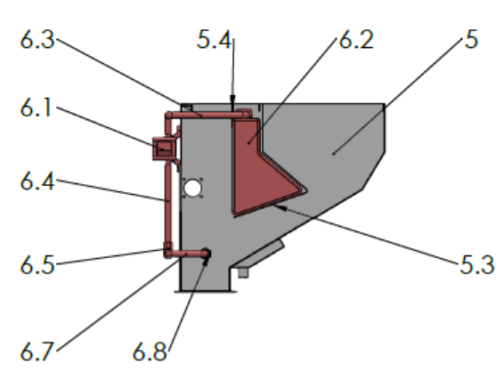

[Fig.7]
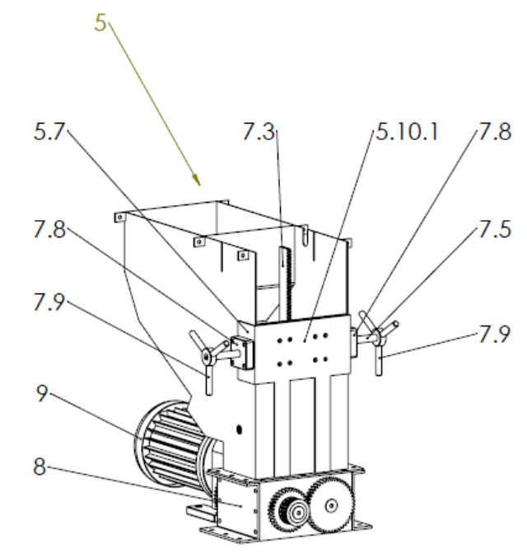

[Fig.7A]
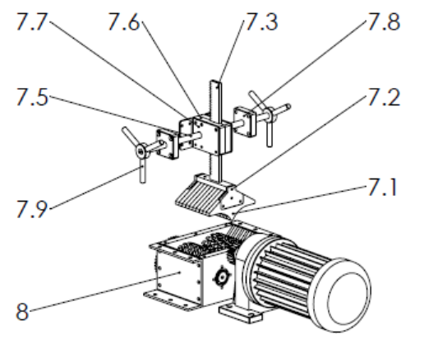
[Fig.7B]
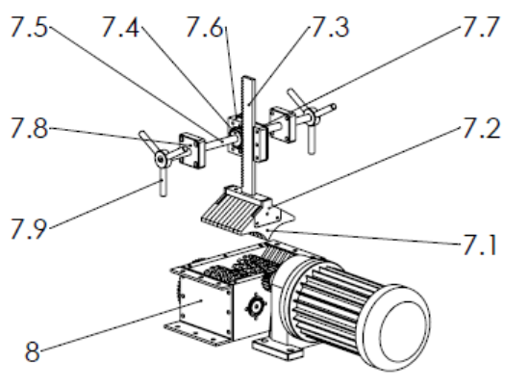

[Fig.7C]
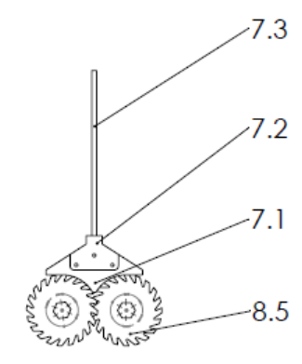
[Fig.7D]
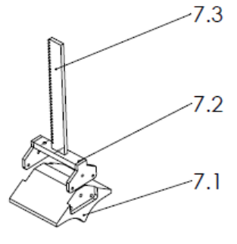

[Fig.7E]
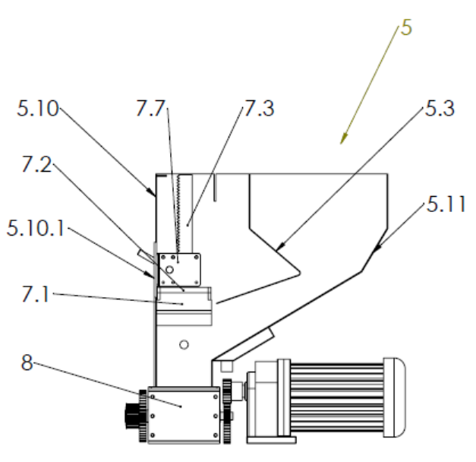

[Fig.8]
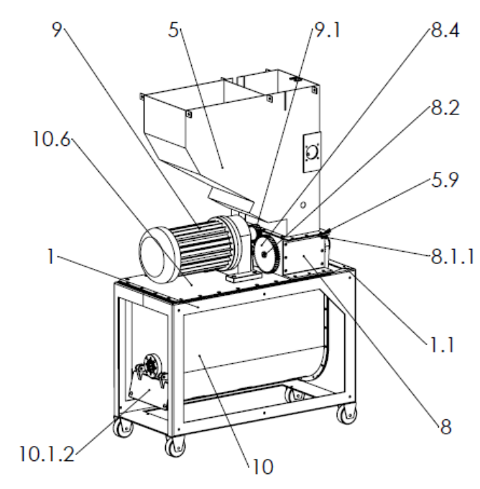

[Fig.8A]
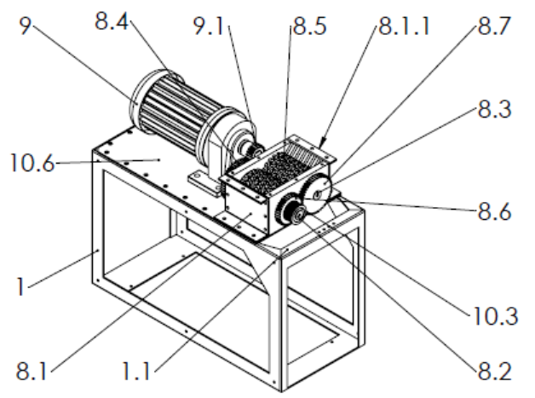
[Fig.8B]
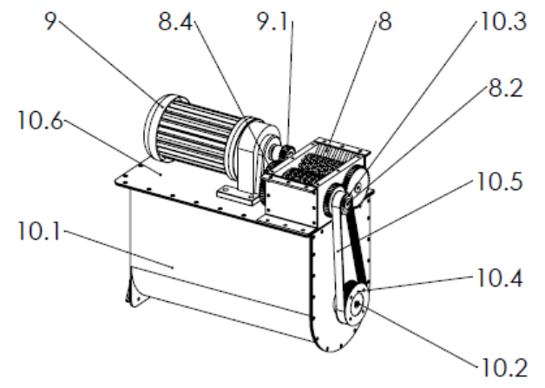
[Fig.9]
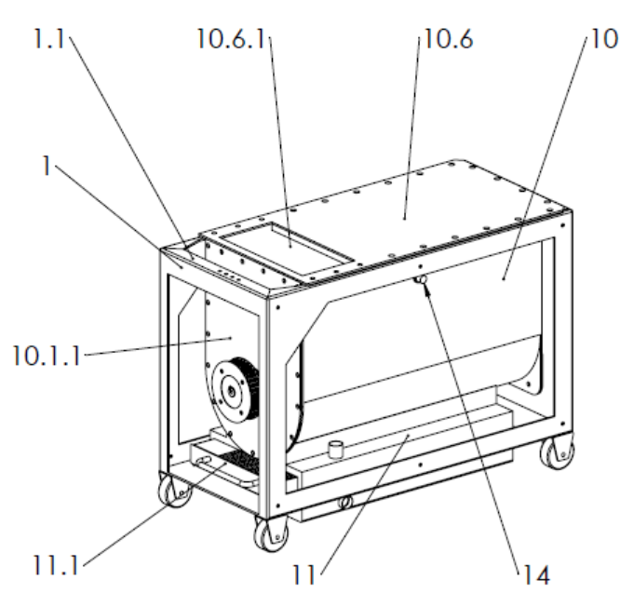
[Fig.9A]
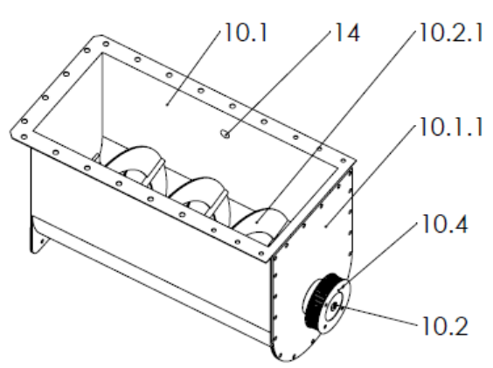
[Fig.9B]
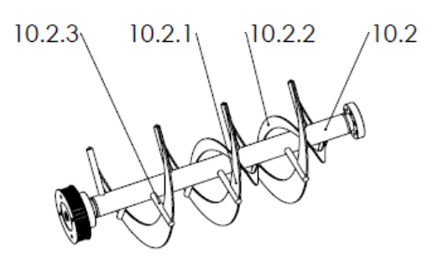
[Fig.9C]
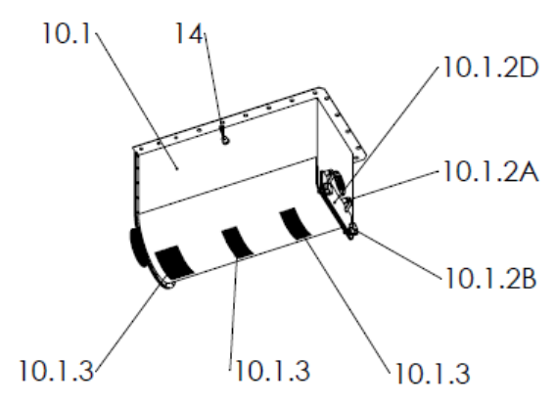

[Fig.9D]
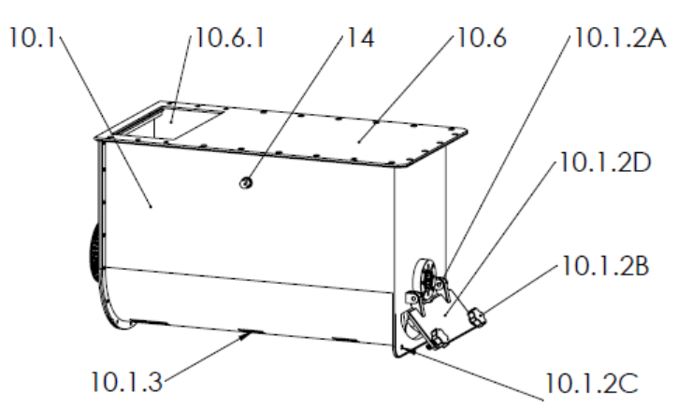
[Fig.10]
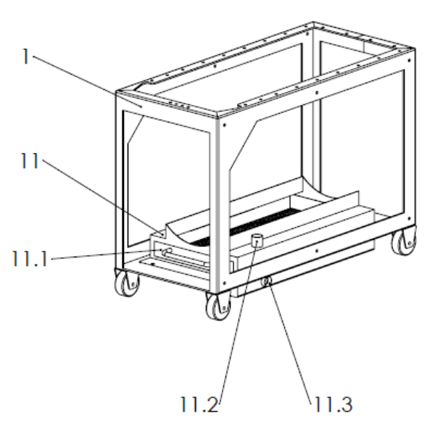
[Fig.10A]
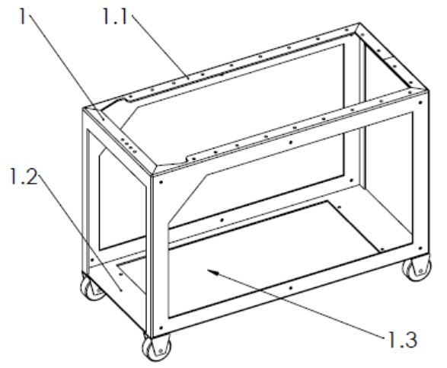
[Fig.10B]
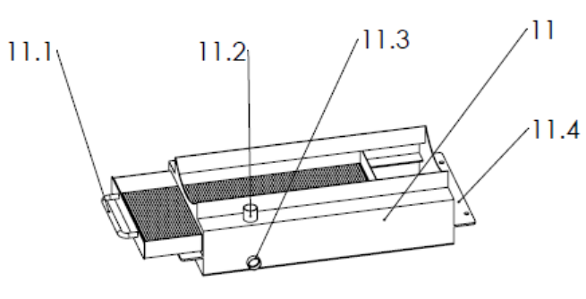

[Fig.10C]
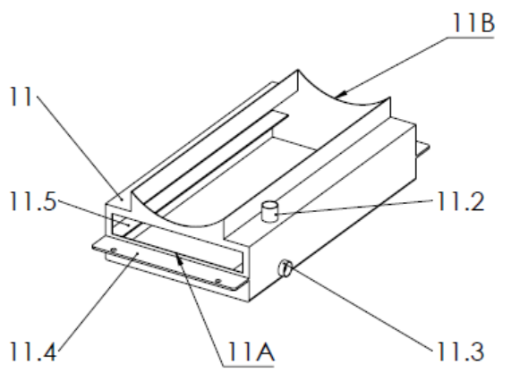
[Fig.10D]
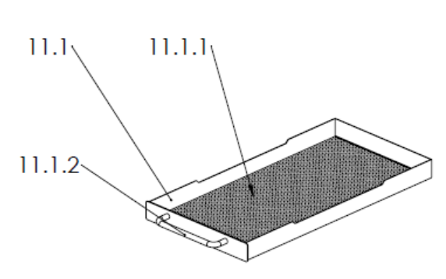

[Fig.10E]
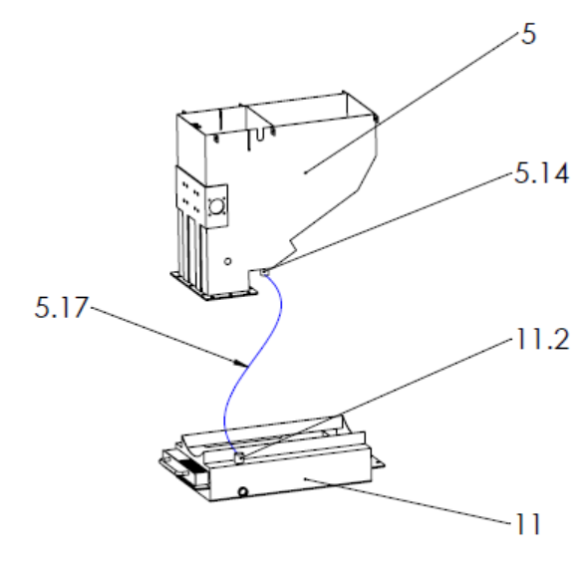

[Fig.11]
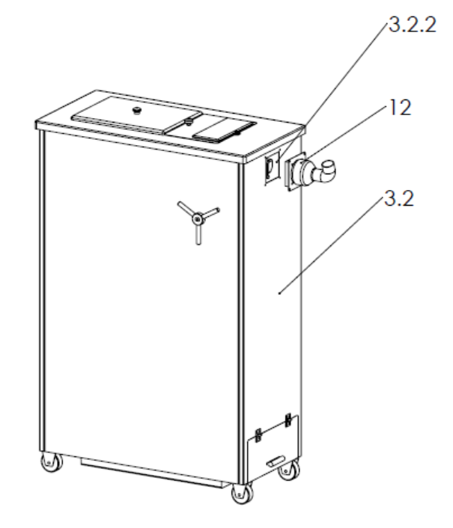

[Fig.11A]
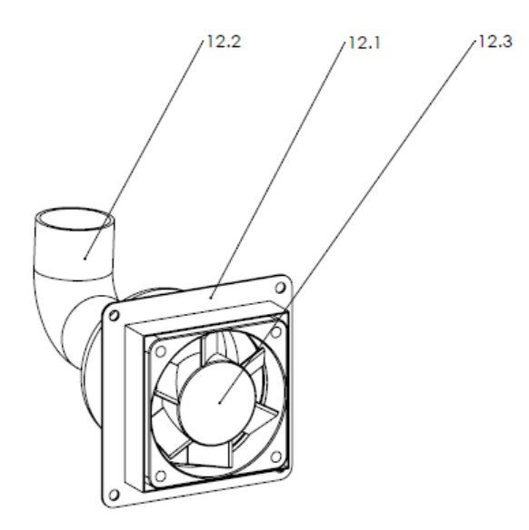
[Fig.12]
