Trademarks, Geographical indications.
During the reporting period, 5856 applications, (including the applications from the Nakhchivan Autonomous Republic), concerning the registration of Trademarks, İndustrial designs and Geographical indications, were received.

İnformation concerning the number of received applications, the number of notifications, inquiries and references on applications, sent to the applicants and to the patent attorneys.

The number of received applications on the registration of Trademarks | The number of received applications on the registration of Geographical indications
2317, including the number of applications that must be examined expeditiously (within a month) on the request of the applicant-700 | Not received
The number of notifications on trademarks claims | The number of notifications on Geographical indications claims
3270 (including the notifications of 2018 applications, which are still at the stage of examination) | 8(concerning the applications of 2018)
Reference (at the stage of preliminary examination) | notification of withdrawal of the claim
2155 (including the notifications of 2018 applications, which are still at the stage of examination) | 4
İnquiry-391 | Decision on registration-  7
notification of withdrawal of the claim-64
Decision-1557 (including the notifications of 2018 applications, which are still at the stage of examination)
notification of refusal-278
decision of refusal-61

Applications received from the Nakhchivan Autonomous Republic to the department of examination of national Trademarks, İndustrial designs, Geographical indications of the Patent and Trademarks Examination Center.
Applications received on national trademarks
56

İnternational trademarks. Applications on trademarks received for the registration from the İnternational Bureau of WİPO in Azerbaijan, covers the 70 country- for 2018, 50 country-for 2019 year. (The number of positive and negative decisions is given in Table 3)

Information about the work done in the field of registration of
Trademarks, received for the registration from the
İnternational Bureau of WİPO in Azerbaijan

Madrid agreement about the international registration of trademarks and the number of received notifications according to this protocol.
3307
the number of decisions of refusal

149
Application for the international registration of a trademark by local applicants

8
The number of decisions on registration of a trademark, on condition of not giving a legal protection for certain elements contained in it.

41

From the 2265 of the applications, that included into the stage of examination, (except the applications that received for the registration from the İnternational Bureau of WİPO in Azerbaijan), a positive decision was made about 1557 trademarks and 61 signs were denied on registration.

Grounds for the refusal are the followings:
Absolute grounds for refusal of registration of trademark
-The similarity between marks (sometimes being the same)
-lack of distinctive feature of the mark, statement of the purpose of the goods and services,
- trademarks that are liable to mislead the consumer, to geographical origin of the goods or service;
Information on decisions reviewed by the supervisory board of the center of expertise
1) During 2019, expert decision (opinion) on registration of 1721 national trademarks, discussed by the Supervisory Board of the Center of Expertise, was considered expedient. 78 Expert decision (opinion) on registration of a trademark was not considered expedient.
2) During the reporting year, 184 decisions on international trademarks, was discussed at the Supervisory Board of the Center of Expertise (145 refusals, 39 concerning not giving a legal protection to the certain elements), 2 refusals and 1 expert decision (opinion) on registration, on condition of not giving a legal protection for certain elements contained in it, considered expedient.

Registration and inclusion of industrial property objects into the Register.
During 2019, works on the improving the normative-legal and information base in the field of protection of intellectual property rights by the Intellectual Property Agency of the Republic of Azerbaijan, State registration of industrial property objects in accordance with the current legislation and international agreements and treaties to which the Republic of Azerbaijan is a party, issuance of relevant security documents, their maintenance, maintenance of the state register of industrial property , making changes in the information on registration in the state register and certificate and issuing relevant notifications, issuance of duplicates, the issuance of extracts from the register, the registration of agreements on the transfer of rights to industrial property to other persons, licensing agreements on the issuance of the right to use, were carried out.
Expansion of cooperation with relevant international organizations in the field of industrial property, fulfillment of obligations of the Republic of Azerbaijan arising from international treaties and agreements, answering and conducting inquiries of international organizations on intellectual property, holding joint events with international organizations, and other works have already done.
Cooperation of the Republic of Azerbaijan with international organizations, the World Intellectual Property Organization, the European Patent Office, the Eurasian Patent Office and patent structures of a number of foreign countries has been developed.

TRADEMARKS. During the reporting period, 1114 trademarks were registered in the relevant State Register, of which 642 belonged to national and 472 to foreign individuals and legal entities. Information on the countries to which the owners of 2019 registered trademarks belong, is shown in the table and diagram.
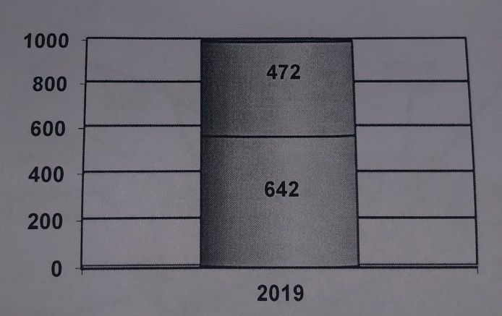
□national 2019 □foreign

Five certificates of use rights for geographical indications have been registered in the name of a national legal entity.
486 notifications of changes on trademarks and 86 contracts on industrial property objects has been registered. 81 of them to grant rights to trademarks; 3 trademarks refer to the issuance of a license for the right of usage.
During the reporting period, information on the legal status of industrial property objects and their subsequent changes, authors, claimants and owners, issuance of rights to industrial property objects, license agreements for their use and other information in this sphere, included into the register, shall be published in the official "Industrial Property". Bulletin.
"Patent, Trademark Open Target" (PANAH) system
ASAN-type "Patent, Trademark Open Target Digital" (PANAH) information system, which provides patent and trademark applicants without direct contact with experts and other service is about to begin operations. Through this system, it will be possible to conduct all applications related to intellectual property online. Applicants, will be able to receive information and notifications about the submitted documents through the web platform, mobile application and SMS notification service.
The fastest way to get information and track the process


Filing Preliminary examination Publication Payment Granting a certificate
of applications Examination

" PANAH " system:
- acceptance of received claims on inventions, utility models, industrial designs, trademarks and geographical indications;
- preparation of an expert opinion for granting a patent and certificate and sending it to the applicant;
- implementation of other issues in the field of examination of invention, utility model, industrial design, trademark and geographical indications;
- acceptance of documents required for publication of relevant information;
- acceptance of documents on registration, patent issuance and publication of an invention, utility model, industrial design;
- acceptance of documents on registration of trademarks and geographical indications, on publication of information and issuance of a certificate;
- acceptance of documents on registration of contracts;
- acceptance of documents on issuance of duplicate patents and certificates;
- acceptance of documents on registration of changes of the information on registration in the register ;
is a system that facilitates and provides transparency to applicants in the issuance of extracts from inventions, utility models, industrial designs, trademarks and geographical information.
Industrial Property Automation System (IPAS).
The process of integration from the IPOA (Intellectual Property of Azerbaijan) system implemented in Azerbaijan to the IPAS (Industrial Property Automation System) system provided by the World Intellectual Property Organization (WIPO) is about to end.
The "Production" version of this system is expected to be launched soon. The new system will be initially applied to the Trademark Examination Department and at the next stage to the Document Acceptance and Register Departments. The IPOA system will operate in parallel until the IPAS system is fully operational.
IPAS is developed and owned by WIPO and as part of WIPO's technical assistance services, it will be offered free of charge to the IP offices of WIPO member countries. Prior to the start of the project, WIPO and the IP Office (or responsible agency) will sign a cooperation agreement that sets out the joint responsibility for ensuring the terms of use, confidentiality and other provisions of the WIPO software systems.
IPAS is a workflow-based system that can be fully adapted to the requirements and legal framework of each IP office.

